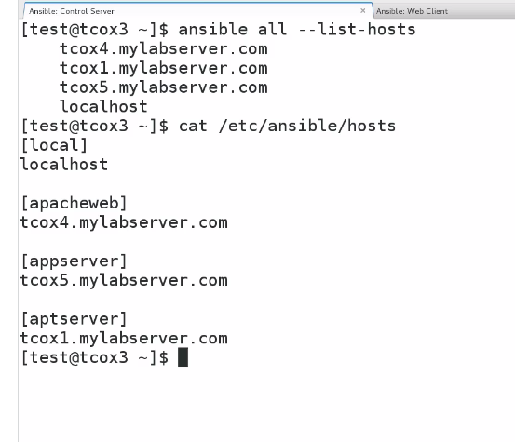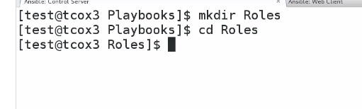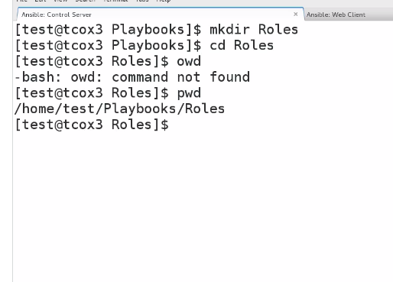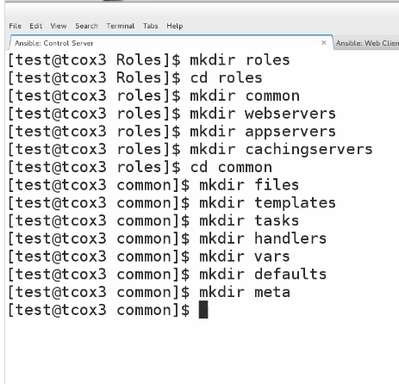

So now make this directory in every section

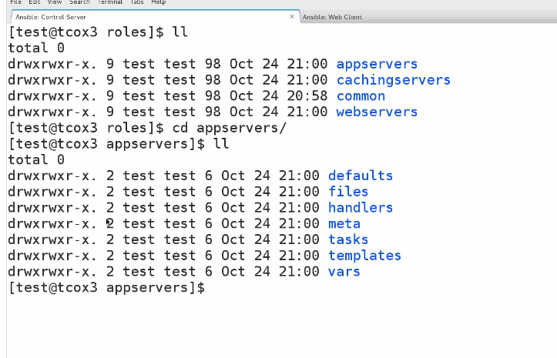

**Exercise: Roles - Create Directory Structure**

1. Verify that your ansible installation is available by displaying the version of ansible while logged in as the 'user' user.

[test@tcox3 ~]$ ansible --version

ansible 1.9.2

  configured module search path = None

2. Run the ansible command that lists all of the hosts configured in your control server 'hosts' file for the system.

[test@tcox3 ~]$ ansible all --list-hosts

    tcox5.mylabserver.com

    localhost

    tcox4.mylabserver.com

3. Create a directory structure using the content directions from the Roles series as follows:

- Top level 'roles' directory

- Roles that include 'webservers', 'appservers', 'cachingservers', 'common'

- Add the appropriate subdirectories so that the automatic include of the 'main.yml' file, if it exists, is included in any master control playbook

[test@tcox3 ]$ mkdir roles

[test@tcox3 ]$ cd roles

[test@tcox3 roles]$ mkdir appservers cachingservers common webservers

[test@tcox3 roles]$ mkdir appservers/defaults appservers/files appservers/handlers appservers/meta appservers/tasks appservers/templates appservers/vars

4. List the directory structure of 'webservers' (which should be identical to the remaining).

[test@tcox3 roles]$ ls -al webservers/

total 4

drwxrwxr-x. 9 test test   98 Oct 26 23:43 .

drwxrwxr-x. 8 test test 4096 Oct 27 21:26 ..

drwxrwxr-x. 2 test test    6 Oct 24 21:00 defaults

drwxrwxr-x. 2 test test    6 Oct 24 21:00 files

drwxrwxr-x. 2 test test   21 Oct 27 20:59 handlers

drwxrwxr-x. 2 test test    6 Oct 24 21:00 meta

drwxrwxr-x. 2 test test   21 Oct 27 21:00 tasks

drwxrwxr-x. 2 test test    6 Oct 24 21:00 templates

drwxrwxr-x. 2 test test   21 Oct 27 00:26 vars